**User Interface Design**

**Report**

CSCI822

Group 2

Xinchi Wang

Rixin Nie

Kaijian Feng

Caixing Su

Akshay Lakhanpal

contents

1. Introduction 3

2. The software used 3

3. User Interfaces 3

3.1. Hardware Interfaces 3

3.2. Software Interfaces 3

3.2.1. User Interface 3

3.3. Communication Interfaces 4

4. Web page UI prototype 4

4.1. web main page 4

4.1.1. Site navigation 5

4.1.2. Question list 5

4.1.3. Page navigation 5

4.1.4. Web relative information 5

4.1.5. Sidebar 6

4.1.6. Tag 6

4.2. question and answer page 7

4.3. ask question page 8

4.4. Navigation diagram 9

# Introduction

In this report, we would introduce the user interface design of the SQA web system. This web system use the Browser/Server model, using web browser, users could access the web system on different types of system environment, such as : Windows，Linux，IOS and Android. And the back ends render the code in java, and the front end used HTML, CSS and JavaScript language.

# The software used

Bootstrap framework, Bootstrap is a popular HTML, CSS, and JS framework for developing responsive, mobile first projects on the web.[1]

Adobe Dreamweaver, Adobe Dreamweaver is a proprietary web development tool developed by Adobe Systems.[2]

# User Interfaces

## Hardware Interfaces

The hardware interfaces depend on the types of user’s browsers and systems.

## Software Interfaces

### User Interface

The user interact with the web system by web browser

Because of using bootstrap framework. The best support browsers are below (other browsers could be used, but might causes some display errors), the browser’s version in below table is updated. And the system supports both IE8 or above versions.

|  |  |  |  |  |  |
| --- | --- | --- | --- | --- | --- |
|  | Chrome | Firefox | IE | Opera | Safari |
| Android | support | support | N/A | nonsupport | N/A |
| IOS | support | N/A | N/A | nonsupport | support |
| MAC OS X | support | support | N/A | support | support |
| Windows | support | support | support | support | nonsupport |

## Communication Interfaces

The user client should communicate with the web server by TCP/IP connection，and the administer of the web system could control the system by ssh connection.

The web server and database server should at least 512MB supported.

# Web page UI prototype

* 1. web main page

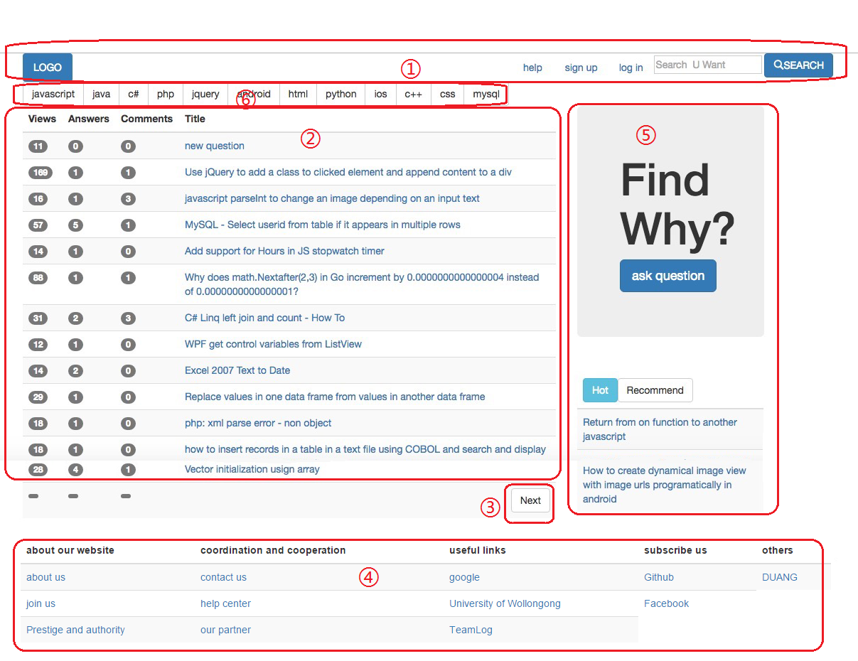

Pic1 main page

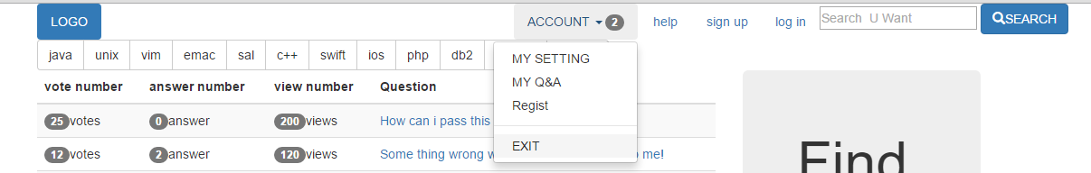

Pic2 drop-down list

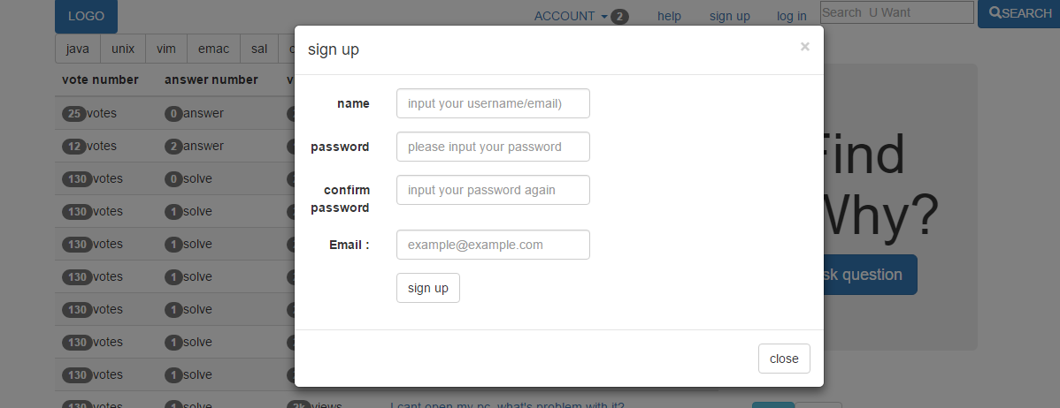

Pic 3 modal dialog

The pic1 is the web system main page. And it was divided into 5 parts. And both part use succinct style, between each parts, the web site leave white space. The system use blue&white style, this is a friendly color style for users, and it is suit for most of network users.

### Site navigation

The ① area of pic1 is site navigation, it only include 6 items which could follow the limited short-term memory principle. And some of the buttons have drop-down list like the pic2 showed, using this navigation and drop-down list, user could get to any pages by 2-3 clicks. For user sign in and sign up, the web system provide a modal dialog for users, this is a prevalent choice by most of web systems, and so for users who have used other web application, it is easy for them to use this web system.

### Question list

The ② area of pic1 is question list, and it succinct style. And it provide a

Intuitionistic list interface, users could easily view the question list, and this list was divided into 4 part: vote, answer, view number and question. We also use span

### Page navigation

The ③ is the system page the question list suit one screen question, and this button would turn to the next page.

### Web relative information

The ④ area of pic1 is Web relative information, and it include some link to relative website, information of web development team. It also have some user help page link.

### Sidebar

The ⑤ area of pic1 is web sidebar. This aspect includes two parts, the first part is a shortcut to ask question page and with a big slogan, it highlight the web system is a question-ask web site. And the next part is some recommend question, it would choose some recommend question by user used search result and some hot question from whole questions.

### Tag

The ⑥ area of pic1 is web tag, it include some hot tag for user to click, and get into a classified question list.

* 1. question and answer page

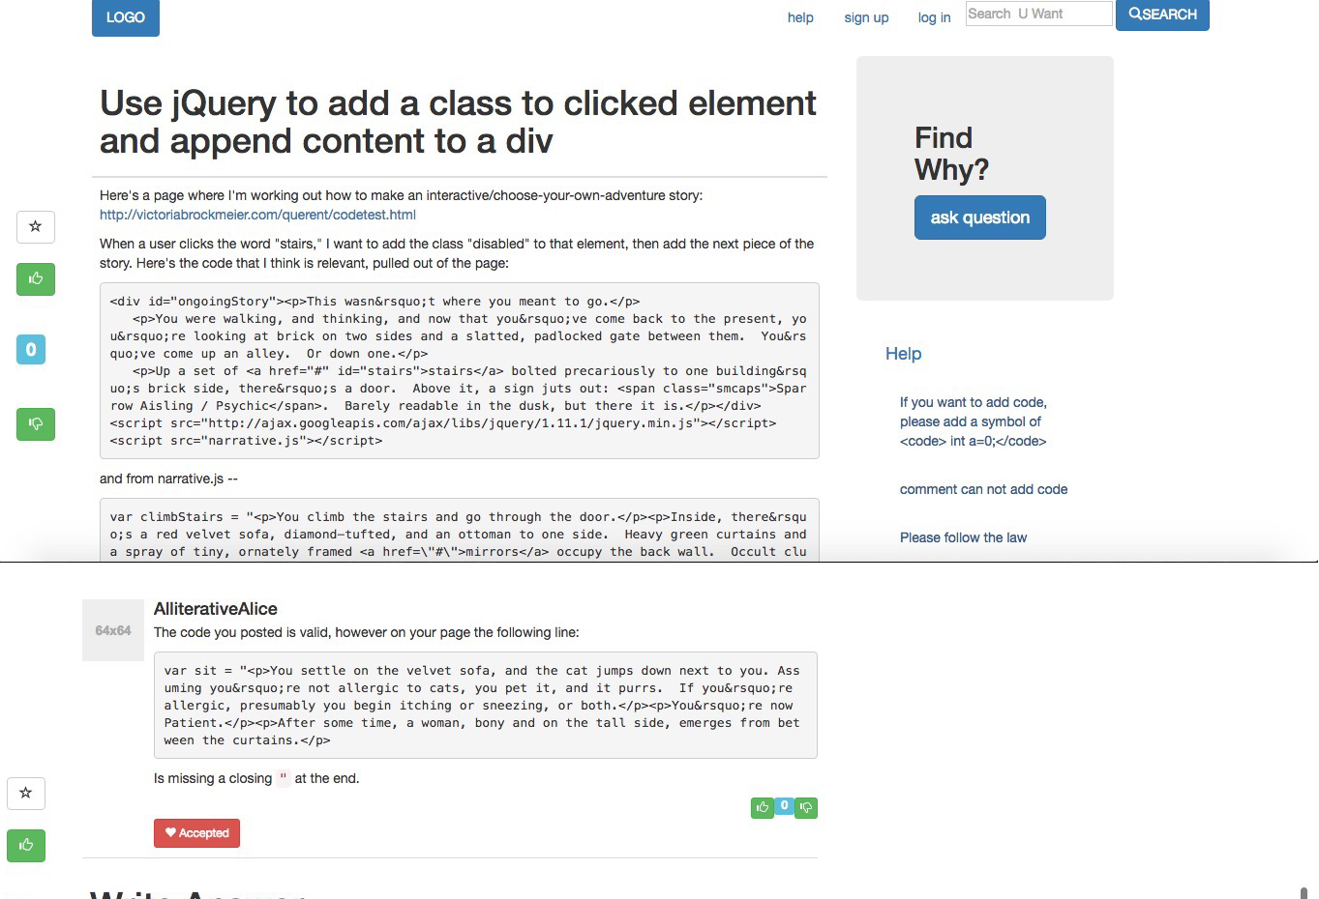

Pic4 question and answer page

This page is a question and answer page. The style follow the main page style. The first part is question part and the second part which separated by black line is the answer part. In question part, it provide some icon such as support and nonsupport and mark, these icon is pleasing to users’ eye. The question support code format, as the pic4 showed code was enclosed in a frame, this is friendly for code reading. Same as the question, the answer part also provide icon support and code reading support.

* 1. ask question page

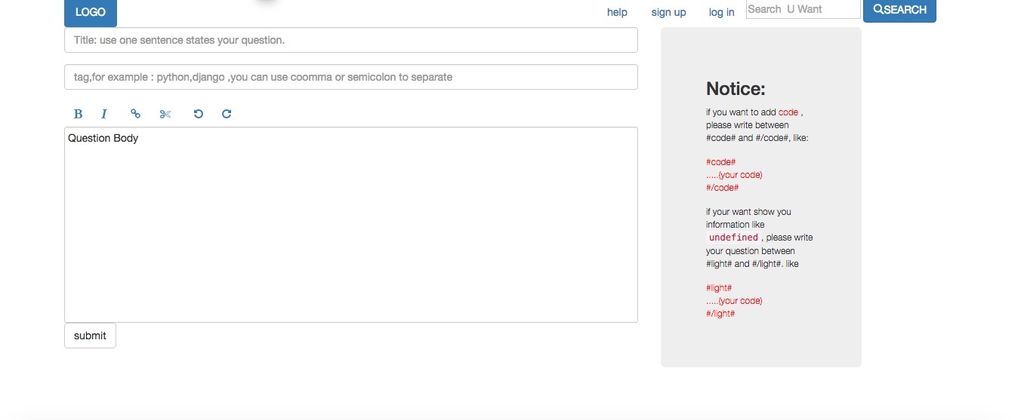

Pic5

This page is a ask question page. This page also follow the style of the main page. And it use a rich text editor for user to edit their question, this is a WYSIWYG (What You See Is What You Get) model,

User could see the text the input up-to-date. And the right side is notice, it provide some example of question and some matters need attention for user upload a question.

* 1. Navigation diagram

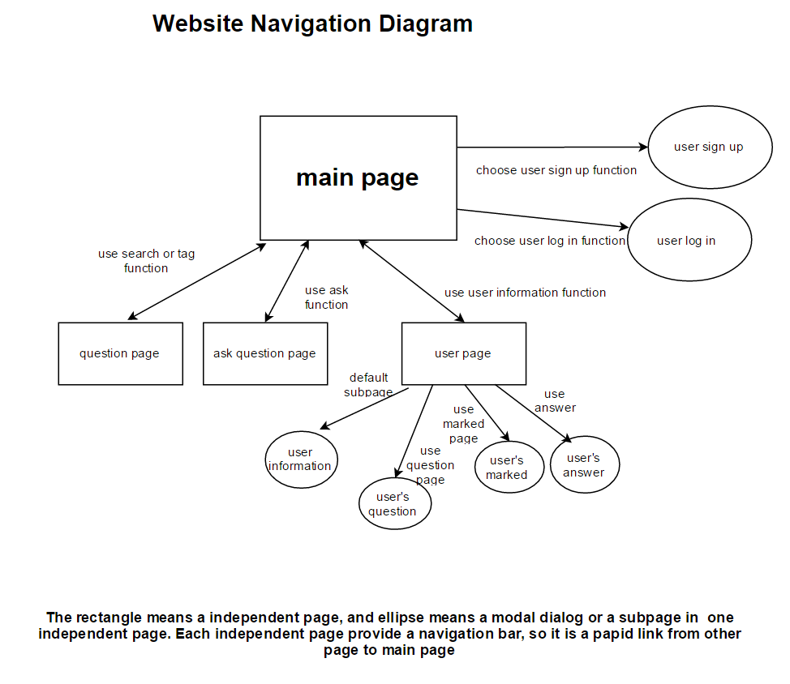

Reference:

1. Mark Otto, a. (2016). *Bootstrap · The world's most popular mobile-first and responsive front-end framework.*. [online] Getbootstrap.com. Available at: http://getbootstrap.com/ [Accessed 27 May 2016].
2. Adobe.com. (2016). *Adobe: Creative, marketing and document management solutions*. [online] Available at: http://www.adobe.com/ [Accessed 27 May 2016].